PENGAJUAN DANA INSPEKSI

1. REMBES FOOTSTEP JEEP SHORT 2015 HITAM B 1780 BJT

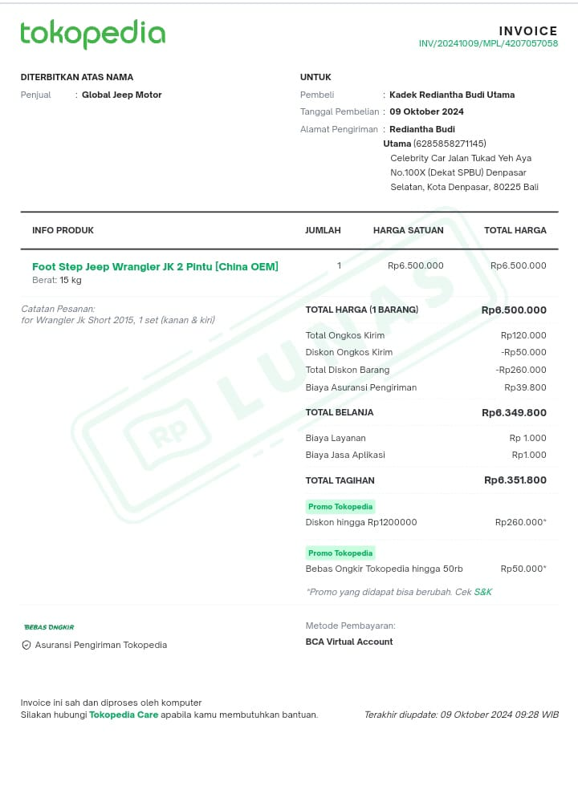

1. KUNCI SEREP PORSCHE MACAN 2017 W 1349 ZQ(via Telfon)
2. SAMSAT MERCY GLA 2017 DK 1684 CE

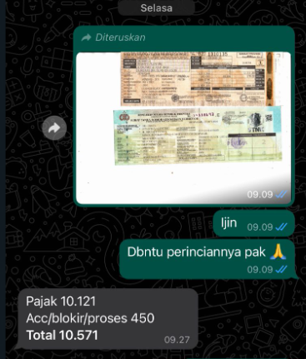

1. SAMSAT BMW X5 2019 D 1420 HA

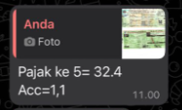

1. FAKTUR BMW x3 DK 1902 FBF

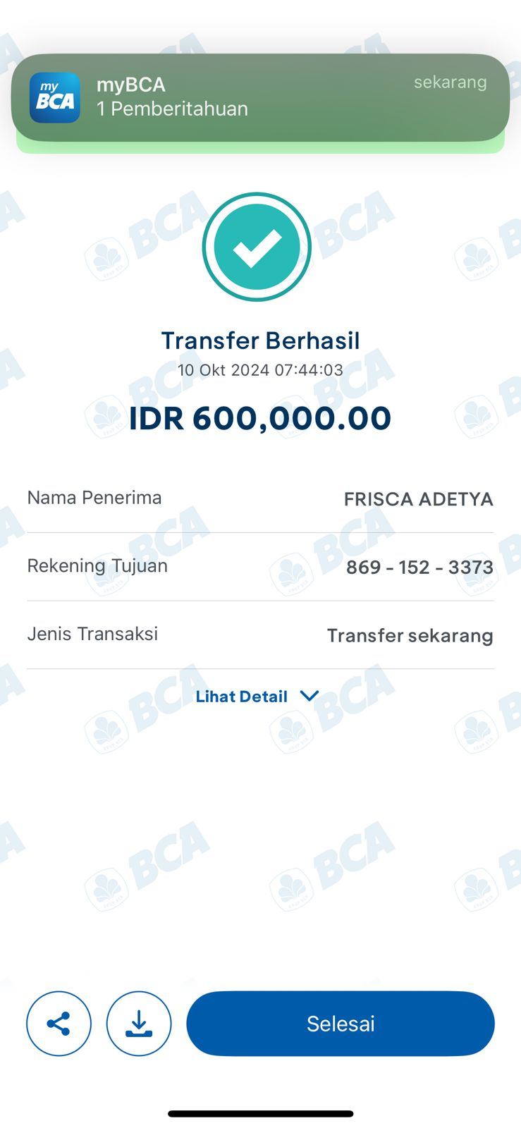

1. SAMSAT MERCY GLC 2021 DD 1908 FL

